17.100: See Problem 17.97. Denoting C by 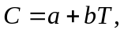 a and b independent of
temperature, integration gives.
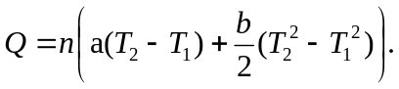
In this form, the temperatures for the linear part may be expressed in terms of Celsius temperatures, but the quadratic must be converted to Kelvin temperatures, 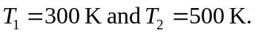 Insertion of the given values yields
